

Software Design Document

Steven Totten
Ryan Spoon
Drew Salyer
Stephanie Kinsella
David Ball
Custom Fit Coding, LLC
April 11, 2011

Revisions
Version | Primary Author(s) | Description of Version | Date Completed
1 | Steven Totten | Initial version of Software Design Document | 04/11/11

Review & Approval
Requirements Document Approval History
Approving Party | Version Approved | Signature | Date
Steven Totten | 1 |  | 04/11/11
D.P. Daugherty | 1

Requirements Document Review History
Reviewer | Version Reviewed | Signature | Date
Steven Totten | 1 |  | 04/11/11
Stephanie Kinsella | 1 | Stephanie Kinsella | 04/11/11

Contents
1 Introduction 1
1.1 System Overview 1
1.2 Supporting Materials 1
1.3 Definitions and Acronyms 1
2 Functional Requirements Mapping Overview 2
3 High Level Design 3
3.1 Conceptual View (Architectural Context Model) 3
4 Low Level Design 4
4.1 Process Model 4
5 User Interface Design 5
5.1 Application Control 5
5.2 Screen 1..n 5

Introduction

System Overview
The Cooking to Goal application will have an easy to navigate graphical user interface which will help customers create and compare meals and menus for a weekly period. Users will select their profile from a list of usernames, or create a username and profile if theirs does not exist. From here, a user will begin creating their weekly menu. They will be able to choose from multiple menu options, allowing them to select a variety of meals while meeting their nutritional goals. A weekly grocery shopping list will be generated based upon their meal selections.
A more detailed statement of scope for this project can be found on page 6 of the Cooking to Goal Software Project Management Plan.

Supporting Materials
Ball, David. Cooking to Goal Software Project Management Plan. Version 2. Radford, Virginia: Custom Fit Coding, LLC; February 21, 2011.
Spoon, Ryan. Cooking to Goal Software Requirements Specification. Version 1. Radford, Virginia: Custom Fit Coding, LLC; March 21, 2011.
“How to Understand and Use the Nutrition Facts Label”, http://www.fda.gov/food/labelingnutrition/consumerinformation/ucm078889.htm

Definitions and Acronyms
Automation Boundary: Set of actions and functions that a user may perform.
Family Member: Person in the application user’s family who is using the application in concert with the user or by themselves.
Guest: A user of the application that chooses not to create a profile within the application.
Guest Actions: Actions that users not registered with the application may perform.
Ingredient: Single piece of a recipe.
Instruction: Direction set given to create a recipe.
Meal: Recipe or multiple recipes combined.
Meal Plan: Set of meals for a given period of time (i.e. a week)
Nutrition Information: Nutritional values given for each item to include information such as total carbohydrates, fat, sodium, fiber, etc.
Nutrition Plan: Set of goals a user has for their nutritional intake.
Nutrition Plan Editor: Means to edit user’s nutritional goals.
Nutrition Plan Effectiveness (%): How effective a given users nutritional goals are.
Recipe: Multiple ingredients combined together.
Recipe Editor: Means to add, modify or delete a recipe from the application.
Shopping List: List of items necessary to be bought in order to cook the chosen recipes.
System Boundary: How users (to include guests and family members) interact with the functions and actions the application is capable of performing.
User: Person utilizing the application who has created a profile.
User Profile: Selections each user may make in order to personalize their goals and meal preferences.
User Profile Actions: Actions available for a particular type of person using the system. Users, guests and family members may all have different actions and functions available to them.
User Profile Home: Identifies the user in some way, such as by their nutritional goals or by their selected meal plan.
User Registration: the area in which a user can complete a registration form order to gain access to the system.

Functional Requirements Mapping Overview
Functional Requirement | Design Artifact
2.1: User Maintenance  Users can add their profile to a list and retrieve their profile when beginning the program. | Figure 2.1: User Maintenance Sequence Diagram  This diagram depicts the information flow for the User Maintenance screen.
2.2: Meal Planner  This is the main area in which user will develop their weekly menus. | Figure 2.2: Meal Planner Sequence Diagram  This diagram depicts how recipes are added and removed from the weekly menu.
2.3: Manage Recipes  This requirement allows the user to add, edit or delete recipes to their particular liking. | Figure 2.3: Manage Recipes Sequence Diagram  This diagram shows the information process in which recipes are managed.
2.4: View Nutritional Goals  This requirement allows a user to create, view and edit their nutritional goals for the week. | Figure 2.4: View Goals Sequence Diagram  This diagram shows how a user’s goal information is processed within the system.
2.5: Print Shopping List  This requirement will generate the shopping list needed for the user to purchase the necessary ingredients for creating their meals for the weekly menu. | Figure 2.5: Print Shopping List Sequence Diagram  This diagram depicts how a shopping list will be created within the system.
2.6: Print Recipe  Similar to the Print Shopping List, this requirement will allow users to print single recipes for sharing or distribution. | Figure 2.6: Print Recipe Sequence Diagram  This diagram will show how a single recipe will be generated and printed within the system.

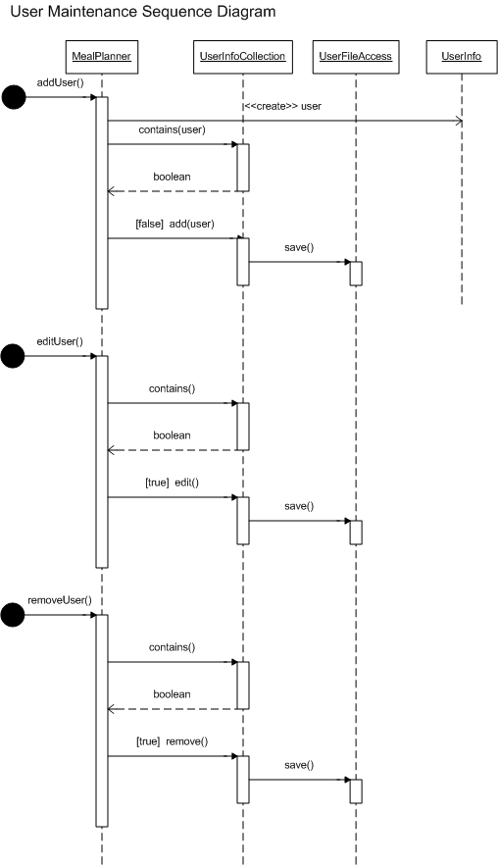
Figure 2.1

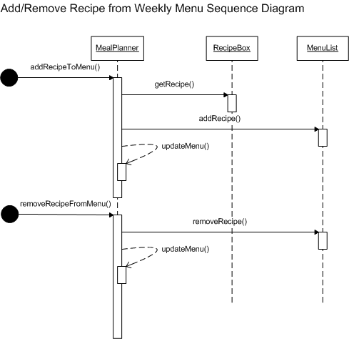
Figure 2.2

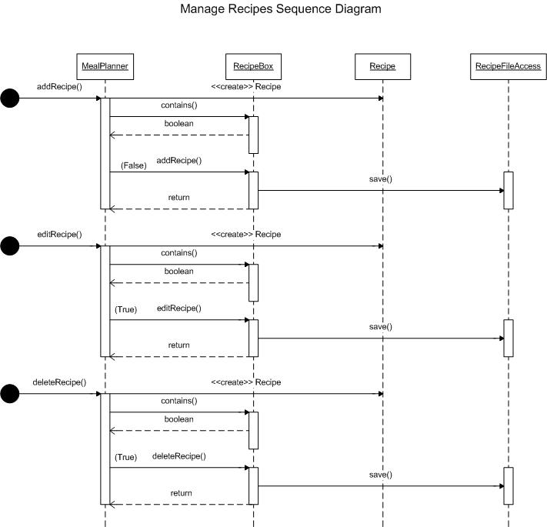
Figure 2.3

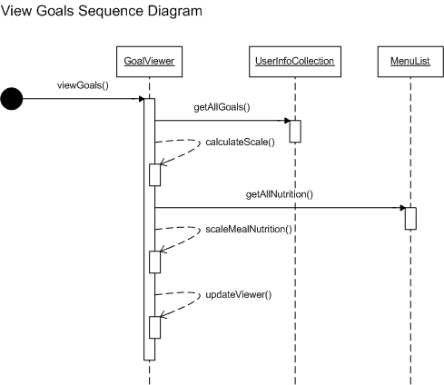
Figure 2.4

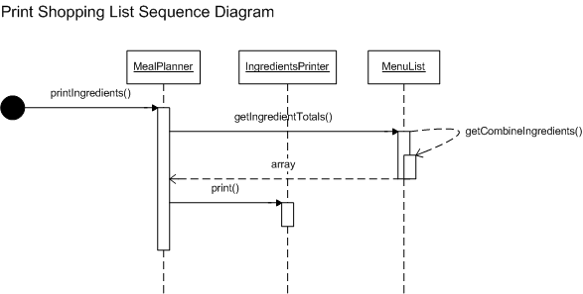
Figure 2.5

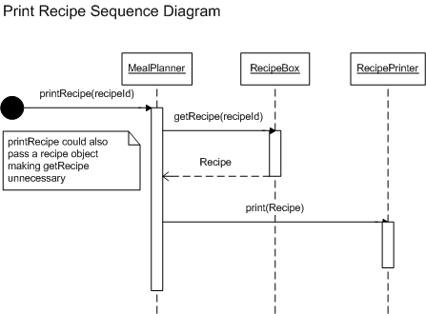
Figure 2.6

High Level Design

Conceptual View (Architectural Context Model)
This class diagram depicts how the major classes will interact with each other in order to bring this application to functionality.

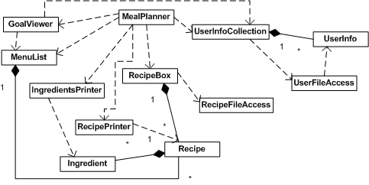

Low Level Design

Process Model
This diagram is a more detailed description of how the classes will work. Attributes and methods are included to give a greater picture of how these classes will operate.

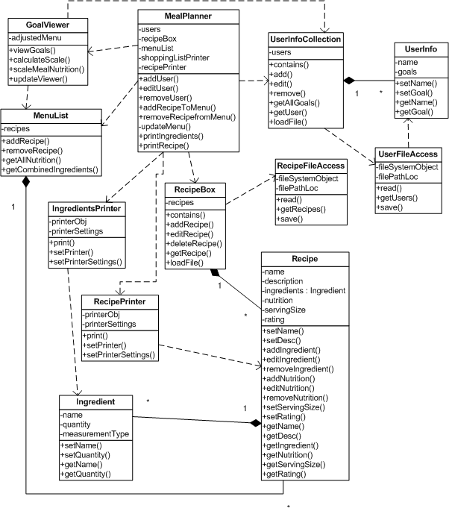

User Interface Design

Application Control

This screen navigation diagram shows how users will navigate through the various screens of the application.

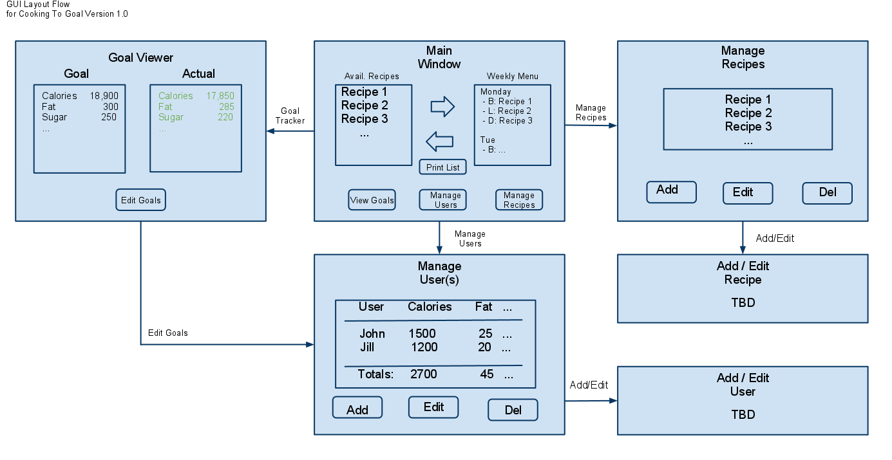

Program Screens
5.2.1 The Meal Planner screen (Figure 5.2.1) is the main window of the application. From here, the user may select yeah…from predefined recipes to add to their weekly meal plan or choose to add their own recipes to the system. As meals are added to the weekly meal plan the application will calculate the necessary serving sizes to stay within the designated nutritional goals.

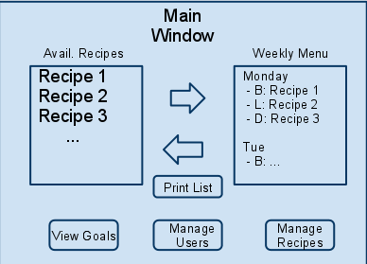
Figure 5.2.1

5.2.2 The User Maintenance screen (Figure 5.2.2) is the container for user details such as name, age, nutritional goals, etc. Users may add, edit, or delete their profiles from within this feature. Upon the first initial launch of the program, if a user does not wish to enter their information immediately, a default profile is loaded so that the user may explore the system immediately. The user may claim the default profile at any time, as well as add additional profiles for family members or guests who also have nutritional goals.
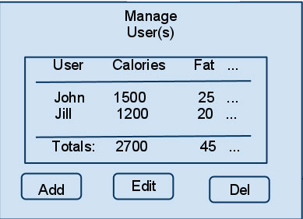
Figure 5.2.2

5.2.3 The Manage Recipes screen (Figure 5.2.3) allows users to enter their own recipes to the meal selection menu as well as edit and delete recipes from the meal list. Recipes will include a name, the nutritional information for the prepared recipe, ingredients, cooking instructions, serving size, and a user rating.
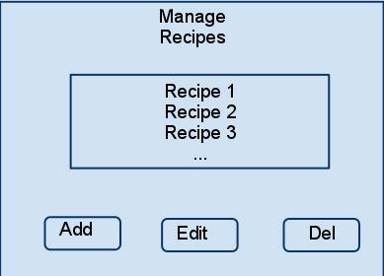
Figure 5.2.3

5.2.4 The Goal Viewer screen (Figure 5.2.4) provides the ability to view the combined nutritional goals of all of the users in the system, side-by-side with the scaled nutritional totals of their weekly meal selections.
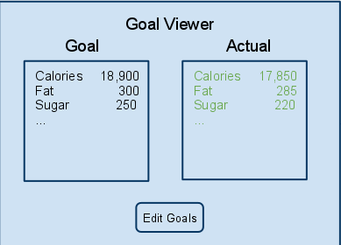
Figure 5.2.4

